Use this address on your Sat Nav: Armouries Drive, Leeds, LS10 1LE. Follow road sign directions for the CitiPark – Leeds Dock car park.
- Drive past the CitiPark car park on your left.
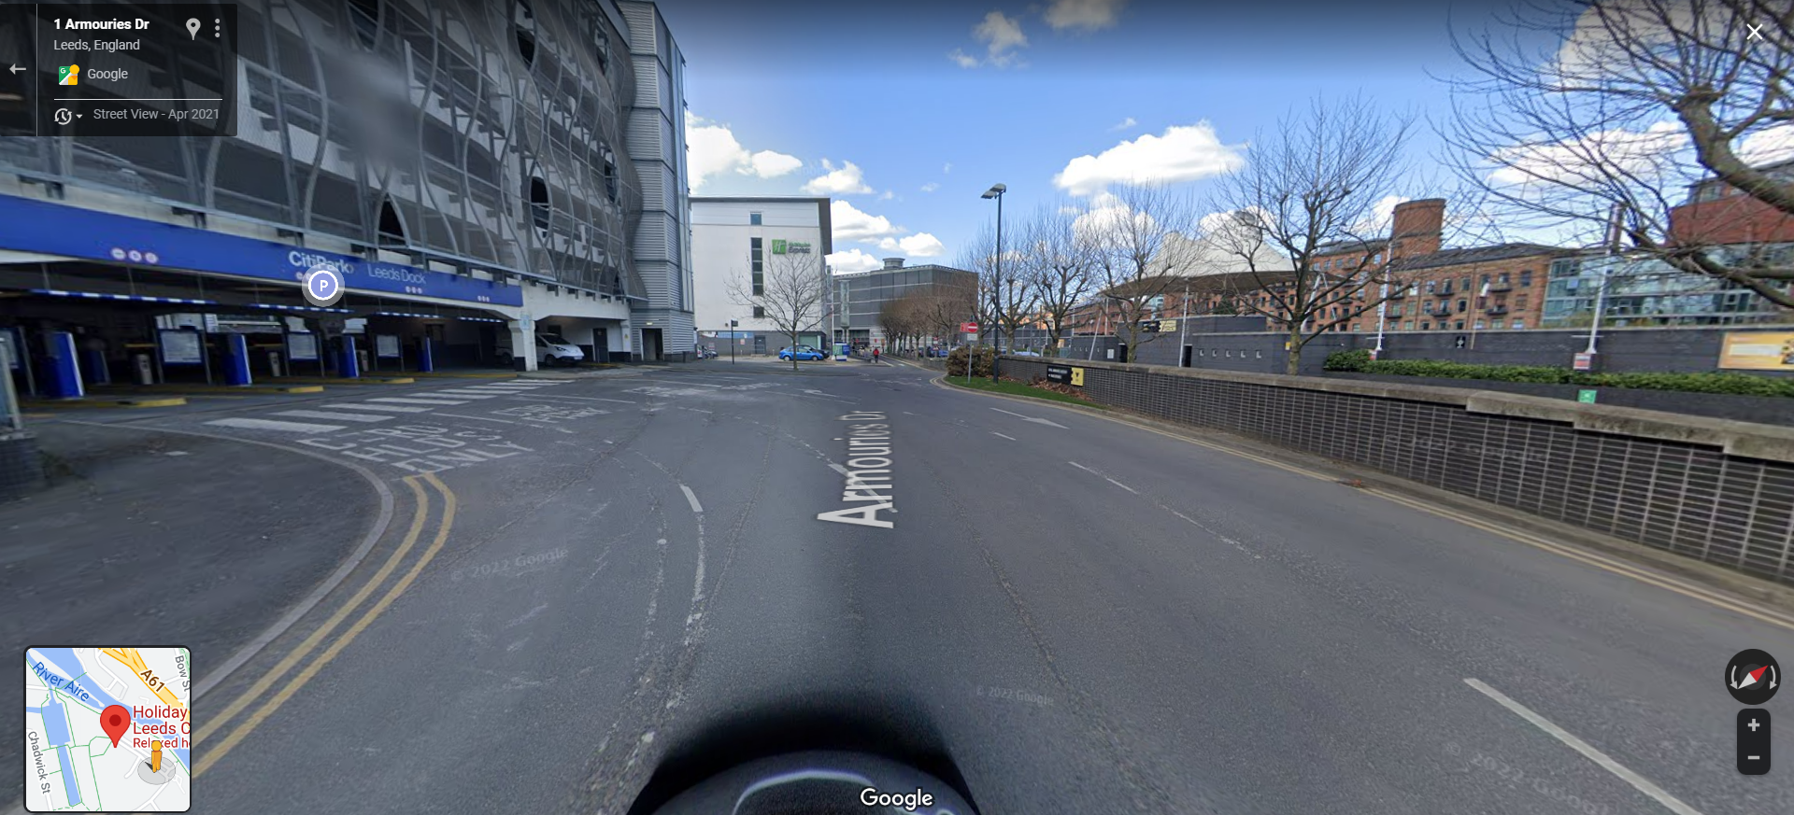
- Turn left after the car park, in front of the Holiday Inn Express hotel.
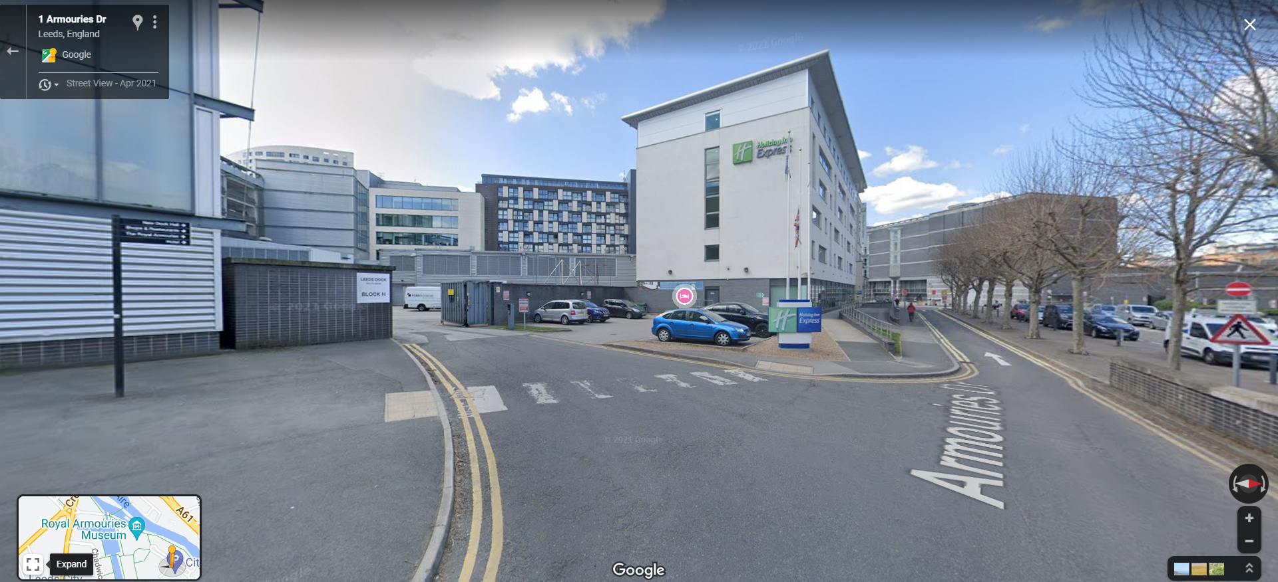
- This will take you to the back of New Dock Hall, for loading.
